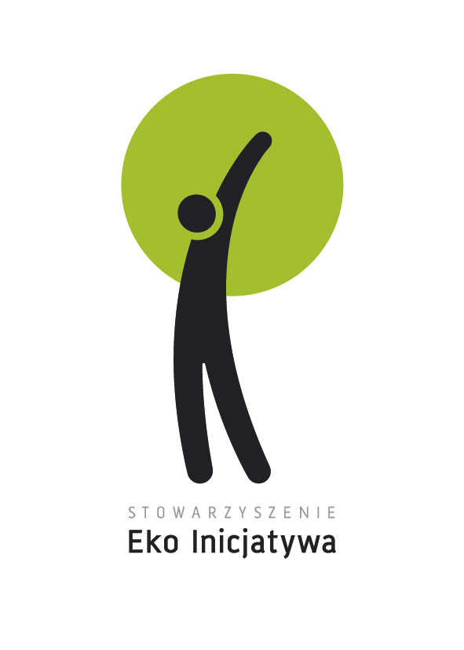
Healthy and conscious way of being
16 au 22 July 2013, Benowo, Poland

What is a youth exchange?
A youth exchange allows different group of youth from different country to realise a project together. It requires active participation of the youth and it’s a way to aware about the social and cultural differences, learn from each others, develop their entrepreneurship and feel more Europeans citizenship.

About the project
Our main aim is to:
Increase activism in local communities in the area of healthy lifestyle amongst young people. The aim will be achieved through getting to know the knowledge on healthy food, value of local products and traditions.
After the training course participants will:
- Understand better what is local diversity in the area of products and traditions,
- know more about their impact on environment,
- be able to identify which products are made in a sustainable way (conscious consumer),
- be able to create projects that will popularize the knowledge on healthy lifestyle in local communities,
- know various tools and methods that can involve other young people into healthy way of being,

Participants of the youth exchange:

This youth exchange is meant for a group of minimum 16 persons (8 persons from partner country, 8 persons from Poland) who:

- are interested in subject of healthy lifestyle;
- value the subject of healthy food and lifestyle and have an interest in exploring it;
- are motivated to develop their own project and spread information in this area afterwards;
- are committed to attend for the full duration of the youth exchange;
- are between 15 and 25 years old;
- are residents of the Youth in Action Programme Countries (27 EU countries + Norway, Iceland, Liechtenstein, Switzerland, Turkey and Croatia).

Working language:

The working language of the youth exchange will be English.

Fees: 20€ to join the association Concordia + 30% of the transport

For more information contact :
Concordia Aquitaine
14 rue de l’Eglise
33880 St Caprais de Bordeaux,
cd.aquitaine@concordia.fr,
05 56 78 76 46

