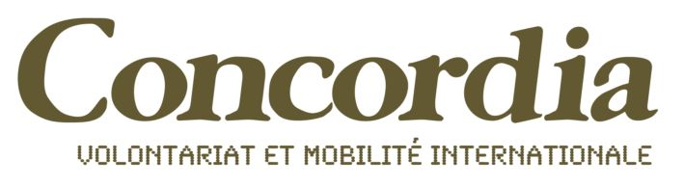
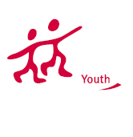
Youth In Action Programme

APPLICATION FORM

« Healthy and conscious way of being »
Dates: from the 16th to the 22th of July 2013
Location: Poland, Benowo

Please return this form to: cd.aquitaine@concordia.fr

PERSONAL INFORMATION:
Name/Surname:…………………………………………………………………………………………………
Address:……………………………………………………………………………………………………………
City: ………………………………………………… Postcode: ……………………………………………..
Phone :…………………………………………………… Email:……………………………………………………...
Date of birth:……………………………………………………………………………………………………..
Languages:………………………………………………………………………………………………………

Contact in case of emergency: ……………………………………………………………………………………………………………………………………………………………………………
Special needs (or health remarks): …………………………………………………………………………………………………………………………………………………………………………………………………………………………………………………………………………………………………………………………………………………………

MOTIVATIONS:
What are your motivations to participate in this youth exchange?

What are your expectations about the youth exchange?

Thank you for your application!

